# Task P7.1.5

## Create a view that joins the tables Customers, Orders and Order_Details and name it CustOrderItems.

**Without Creating view**

SELECT Customers.CustFirstName, Customers.CustLastName, orders.OrderNumber, orders.OrderDate, orders.ShipDate, order_details.QuotedPrice * order_details.QuantityOrdered as ItemTotal FROM customers JOIN orders ON customers.CustomerID = orders.CustomerID JOIN order_details ON orders.OrderNumber = order_details.OrderNumber

**With creation of view**

CREATE VIEW CustOrderItems AS SELECT Customers.CustFirstName, Customers.CustLastName, orders.OrderNumber, orders.OrderDate, orders.ShipDate, order_details.QuotedPrice * order_details.QuantityOrdered as ItemTotal FROM customers JOIN orders ON customers.CustomerID = orders.CustomerID JOIN order_details ON orders.OrderNumber = order_details.OrderNumber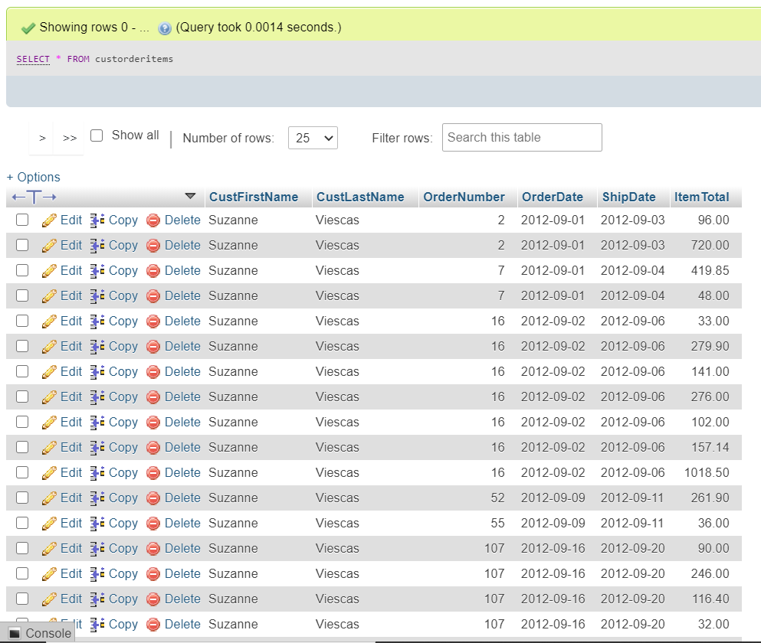

## Using the CustOrderItems view, write a query that shows the orders with customer numbers and order totals in this form

SELECT CustFirstName, CustLastName, OrderNumber, ShipDate, OrderDate,

SUM(ItemTotal) AS OrderTotal FROM custorderitems GROUP by OrderNumber

